LAB EXPERIMENT 10
NAME:Furthose samreen B
REG NO:192511164
10.Demonstrate how to work with Git branches and resolve merge conflicts when collaborating with others. Tasks:
1. Clone a shared repository to your local machine.
2. Create a new branch and switch to it
3. Make changes to a file (e.g., update a README or modify code in a specific function).
4. Commit your changes.
5. Push the changes to the remote repository.
6. Before merging, pull the latest changes from the main branch.
7. Switch back to your feature branch.
8. Merge the main branch into your feature branch.
9. If there are conflicts, resolve them manually by editing the conflicting files. After resolving conflicts, mark the conflicts as resolved.
10. Commit the resolved merge.
11. Push your feature branch with the merged changes to GitHub and create a pull request.

AIM
To demonstrate how to work with Git branches, make changes in a feature branch, merge the latest changes from the main branch, resolve merge conflicts, and push the updated branch to GitHub using a pull request.

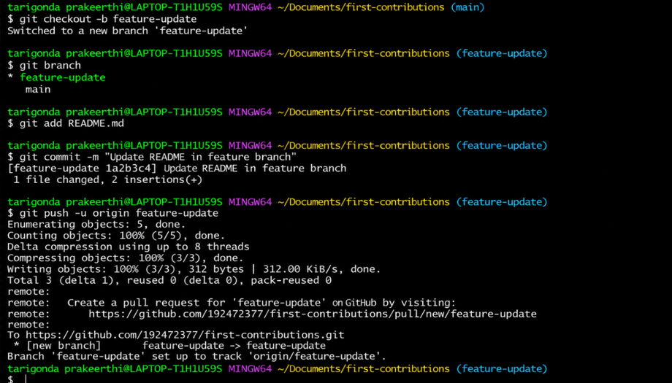
RESULT
Thus, Git branching and merging were successfully demonstrated. Changes were committed and pushed to the remote repository. Merge conflicts were manually resolved, and the updated feature branch was submitted through a pull request on GitHub.

